TECHNICAL PROPOSAL

Pharmaceutical Expo
Mobile Application
Dedicated Android and iOS Application with Admin Dashboard
Prepared by: Riseup Labs


Table of Contents
1. Executive Summary 4
2. Project Understanding 4
3. Project Objectives 4
4. Project Scope and Functional Features 4
4.1 Invite Access and Attendee Authentication 5
4.2 Event Information 5
4.3 Exhibitor and Stand Directory 5
4.4 Expo Floor Plan 5
4.5 QR Code-Based Stand Visit Tracking 5
4.6 Push Notifications 5
4.7 Admin Dashboard 6
4.8 Reports and Analytics 6
5. Role-Based User Journeys 6
5.1 Invited Attendee Journey 6
5.2 Event Administrator Journey 7
5.3 Exhibitor / Stand Representative Operational Journey 7
6. Proposed Technical Approach 7
6.1 Mobile-First Cross-Platform Delivery 7
6.2 API-Centered Backend 7
6.3 Reliable Push Notification Implementation 8
6.4 Controlled QR Visit Recording 8
6.5 Optimized Offline Content 8
6.6 Scope-Controlled Floor Plan 8
7. Solution Architecture 9
7.1 Critical Data Exchange 10
8. Development Methodology 10
8.1 Discovery and Scope Confirmation 10
8.2 UX/UI and Technical Foundation 10
8.3 Iterative Feature Development 11
8.4 Continuous Testing and Stabilization 11
8.5 QA, Store Submission, and Launch 11
9. Proposed Technical Stack 11
10. Non-Functional Requirements 12
11. Security and Data Protection 12
12. Testing and Quality Assurance 12
12.1 Functional Testing 12
12.2 Integration Testing 13
12.3 Device and Compatibility Testing 13
12.4 Performance and Reliability Testing 13
12.5 Security Testing 13
12.6 User Acceptance Testing 13
12.7 Regression and Release Verification 13
13. Deployment and App Store Publishing 13
14. Deliverables 14
15. Assumptions and Client Dependencies 14
16. Out of Scope 15
17. Conclusion 15

1. Executive Summary
Riseup Labs proposes to design and develop a dedicated mobile application for the client’s own pharmaceutical trade exhibition. The solution will support invited attendees on Android and iOS and will be operated through a secure web-based administration dashboard.
The first event is scheduled for 6 September 2026. Accordingly, the proposal uses an accelerated delivery model focused on the agreed critical scope, early validation of push notifications and QR scanning, and timely submission to the Google Play Store and Apple App Store.

2. Project Understanding
The application is intended for the client’s own recurring exhibition and is not a multi-tenant or generic event management product. The same solution can be reused for the client’s annual or multiple yearly editions by updating event content, exhibitors, stand allocations, QR codes, and the floor plan from the administration dashboard.
- The event will be invite-only; attendees receive an invitation email containing event details and application download instructions.
- No payment collection or payment gateway is required.
- Push notifications are the highest priority and must appear through the operating system when the application is backgrounded or the phone is locked, subject to device permissions and platform delivery conditions.
- Each exhibitor or manufacturer stand will receive a unique QR code. A successful scan will create an attendee-to-stand visit record on the server.
- The floor plan is a visual discovery tool. Turn-by-turn navigation, indoor positioning, and live user-location tracking are not required.
- The client will provide the floor-plan source files and relevant event content.
- QR scans are expected to be online and synchronized immediately. Floor plans and general event information should remain available offline where feasible.
- Riseup Labs will assist with Play Store and App Store preparation and submission.

3. Project Objectives
- Provide invited attendees with convenient access to essential exhibition information.
- Enable administrators to broadcast time-sensitive announcements to attendee devices.
- Measure exhibitor engagement through reliable QR-based stand visit records.
- Help attendees visually locate exhibitors using zoomable 2D floor plan.
- Provide practical operational reports without introducing unnecessary event-platform complexity.
- Deliver a stable, lightweight solution in time for the first scheduled event.

4. Project Scope and Functional Features
The functional scope is organized below as simple module-based bullet lists. Features are intentionally limited to the requirements captured in the supplied context and meeting notes.

4.1 Invite Access and Attendee Authentication
- Allow invited attendees to activate or access the application using a controlled credential mechanism linked to the invitation list.
- Validate that the attendee is authorized for the event before granting access to protected event content.
- Maintain a basic attendee profile needed to associate QR scans and notification delivery tokens.
- Provide secure login, logout, and session handling.
- Display clear guidance when an invitation is invalid, expired, or not found.

4.2 Event Information
- Display the current exhibition name, date, venue, summary, and key instructions.
- Allow administrators to create and update the client’s event edition details.
- Make core event information available from local cache after it has been loaded at least once.
- Present a lightweight mobile layout optimized for quick access during the exhibition.

4.3 Exhibitor and Stand Directory
- Display a list of exhibitors or manufacturers participating in the exhibition.
- Show the exhibitor name, assigned stand identifier, and concise profile information provided by the client.
- Allow attendees to search or browse exhibitors and open the relevant stand information.
- Allow administrators to add, edit, activate, or deactivate exhibitor and stand records.

4.4 Expo Floor Plan
- Display the client-provided floor plan inside the mobile application.
- Provide touch-based zoom and pan
- Allow the administrator to upload or replace the floor-plan asset for an event edition.
- Cache an optimized floor-plan version on the device for offline viewing after download.
- Exclude live indoor navigation, route calculation, and real-time attendee positioning.

4.5 QR Code-Based Stand Visit Tracking
- Generate or register one unique QR code for each exhibitor stand.
- Provide an in-app camera scanner for attendees.
- Validate the scanned code against the active event and stand record.
- Record the attendee, stand, event, and scan timestamp after successful validation.
- Synchronize successful scans with the server immediately while online.
- Prevent accidental duplicate submissions according to an agreed duplicate-control rule.
- Show a clear success or error message after each scan.
- Allow administrators to download or print the QR code assigned to each stand.

4.6 Push Notifications
- Allow authorized administrators to compose a notification title and message from the dashboard.
- Send notifications to registered attendee devices through the mobile push notification service.
- Display notifications through the device operating system when the application is in the background or the device is locked, subject to user permission and platform behavior.
- Open the application when the attendee taps a notification.
- Maintain a simple in-app notification inbox or history for messages received by the application.
- Record basic send status and provider response information for operational follow-up.

4.7 Admin Dashboard
- Provide secure administrator login and role-protected access.
- Manage event information and event status.
- Manage invited attendee records required for app access.
- Manage exhibitors, stands, stand identifiers, and QR codes.
- Upload and publish the optimized floor-plan asset.
- Compose and send push notifications.
- View QR scan activity and engagement reports.
- Export agreed reports in CSV format.

4.8 Reports and Analytics
- Show stand-wise unique visitor count.
- Show each attendee’s stand visit history.
- Show overall scan volume and engagement summary for the event.
- Allow filtering by event edition, attendee, exhibitor, stand, and date/time where relevant.
- Allow authorized administrators to export report data for further analysis.

5. Role-Based User Journeys
The following journeys describe how each role is expected to use the solution operationally. They are narrative descriptions rather than user-flow diagrams.

5.1 Invited Attendee Journey
- The attendee receives an invitation email from the client containing event details, the application download link, and access instructions.
- The attendee installs the application from Google Play or the Apple App Store and opens it for the first time.
- The attendee grants notification permission so urgent event messages can appear on the device. The app explains why notification access is needed.
- The attendee signs in or activates access using the invitation-linked credential method agreed during discovery.
- After successful validation, the attendee sees the current event overview and can access exhibitor information, the floor plan, notifications, and the QR scanner.
- Before or during the event, the attendee opens the exhibitor directory to find a manufacturer and checks the stand identifier.
- The attendee opens the floor plan, zooms or pans the map, and visually identifies the exhibitor’s position. The app does not calculate a route or track the attendee’s indoor position.
- At the stand, the attendee opens the QR scanner, allows camera access, and scans the stand’s unique QR code.
- The app validates the code online, submits the attendee and stand visit record, and displays a confirmation. Invalid, inactive, or duplicate scans return a clear message.
- When the administrator sends an announcement, the attendee receives a device notification. Tapping it opens the app and the message is also available in the notification history.
- If connectivity is unavailable, the attendee can continue viewing previously cached event information and the floor plan. QR scan submission requires an online connection.

5.2 Event Administrator Journey
- The administrator signs in to the protected web dashboard.
- The administrator creates or updates the current event edition, including the date, venue, summary, and attendee instructions.
- The administrator imports or enters the invited attendee list used to control application access.
- The administrator creates exhibitor records and assigns each exhibitor a unique stand identifier.
- The administrator uploads the client-supplied floor plan and coordinates stand labels or hotspots with the assigned exhibitor records.
- The system generates or registers a unique QR code for each stand. The administrator downloads the codes for printing and placement.
- Before launch, the administrator verifies event content, floor-plan readability, QR code placement, and notification delivery using test accounts and devices.
- During the event, the administrator writes and sends announcements from the dashboard. The dashboard submits the message to the configured push provider for attendee delivery.
- The administrator monitors scan activity and views stand-wise visitor counts, attendee visit histories, and overall engagement statistics.
- After the event, the administrator exports agreed report data and retains the event edition for historical reference or prepares the next edition.

5.3 Exhibitor / Stand Representative Operational Journey
- The client assigns the exhibitor a stand identifier and provides the printed QR code generated from the administration dashboard.
- The exhibitor displays the QR code visibly at the assigned stand.
- Attendees scan the code through the mobile application during their visit.
- The exhibitor does not require a separate portal or dashboard within the current scope.
- The client’s administrator reviews the resulting stand visit statistics and may share reports outside the system as needed.

6. Proposed Technical Approach

6.1 Mobile-First Cross-Platform Delivery
The mobile application will be built with Expo and Flutter using dart. This approach provides a shared codebase for Android and iOS while retaining access to native capabilities required for camera scanning, notifications, local storage, and app-store distribution. Expo’s current documentation describes one JavaScript/TypeScript project that runs natively across supported platforms and provides a unified notification API for Android and iOS.

6.2 API-Centered Backend
A Laravel REST API will provide authentication, event content, exhibitor and stand management, QR validation, visit tracking, notification orchestration, and reporting. Business rules will be centralized in the backend so that dashboard and mobile behavior remain consistent.

6.3 Reliable Push Notification Implementation
- Collect and securely associate each device push token with the authenticated attendee.
- Use Expo Notifications with the Expo Push Service, which routes Android notifications through Firebase Cloud Messaging and iOS notifications through Apple Push Notification service.
- Use notification payloads appropriate for operating-system display while the app is backgrounded.
- Capture provider tickets or receipts and remove invalid device tokens when identified.
- Test remote notifications on real development builds and physical Android and iOS devices rather than relying only on Expo Go or simulators.
- Clearly communicate that users must allow notification permission and that final delivery remains subject to operating-system settings, connectivity, and platform services.

6.4 Controlled QR Visit Recording
- Encode a non-sensitive unique stand token or identifier in each QR code.
- Validate the active event, invited attendee, stand status, and token on the server.
- Create a timestamped visit record only after successful validation.
- Apply idempotency or a time-based duplicate rule to prevent rapid repeat scans from inflating reports.
- Return immediate success, duplicate, invalid, or connectivity feedback to the attendee.

6.5 Optimized Offline Content
- Bundle essential static assets where practical and cache downloaded event content after successful retrieval.
- Convert the client’s floor-plan source file into an optimized mobile-friendly image or vector representation.
- Use device file storage and application cache for the floor plan and core event information.
- Keep QR scan submission online to ensure immediate central validation and reporting.

6.6 Scope-Controlled Floor Plan
The recommended baseline is a high-resolution 2D floor plan with zoom, pan, stand labels, and optional tappable stand hotspots. A simple 3D visual can be evaluated only if the client supplies suitable assets and it does not threaten the delivery timeline. Indoor navigation and location tracking remain excluded.

7. Solution Architecture
The architecture separates attendee experience, administration, backend services, data storage, push delivery, and app distribution. This provides a practical foundation for reusing the application across future editions of the client’s exhibition.
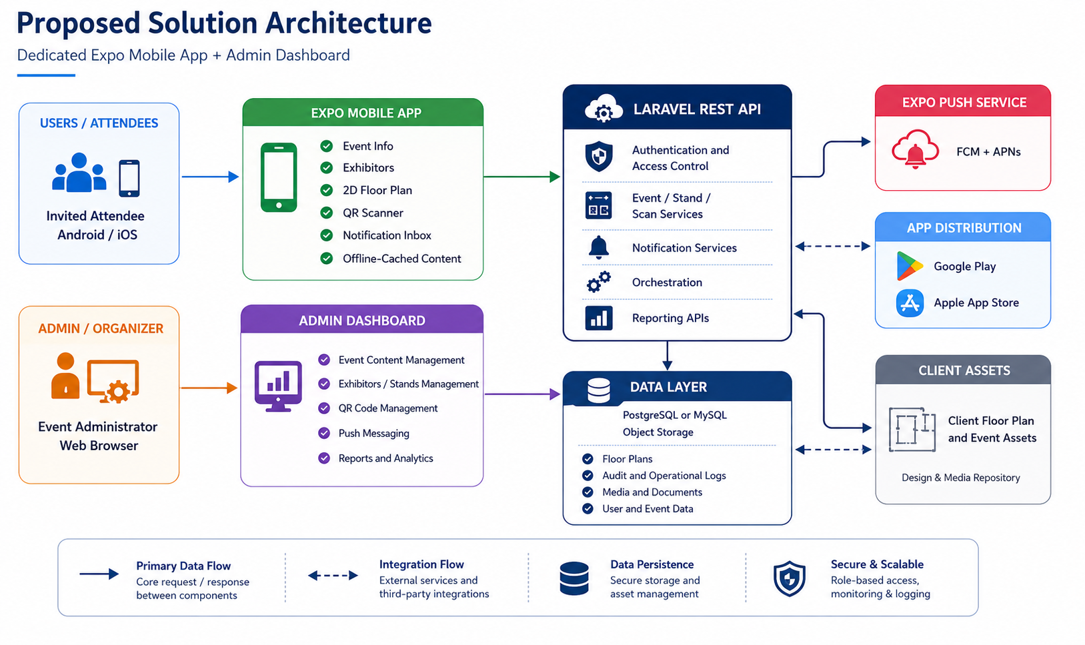
Figure 1. Proposed solution architecture

7.1 Critical Data Exchange
The following technical view highlights the two most important operational exchanges: stand-visit recording and administrator-initiated notification delivery.
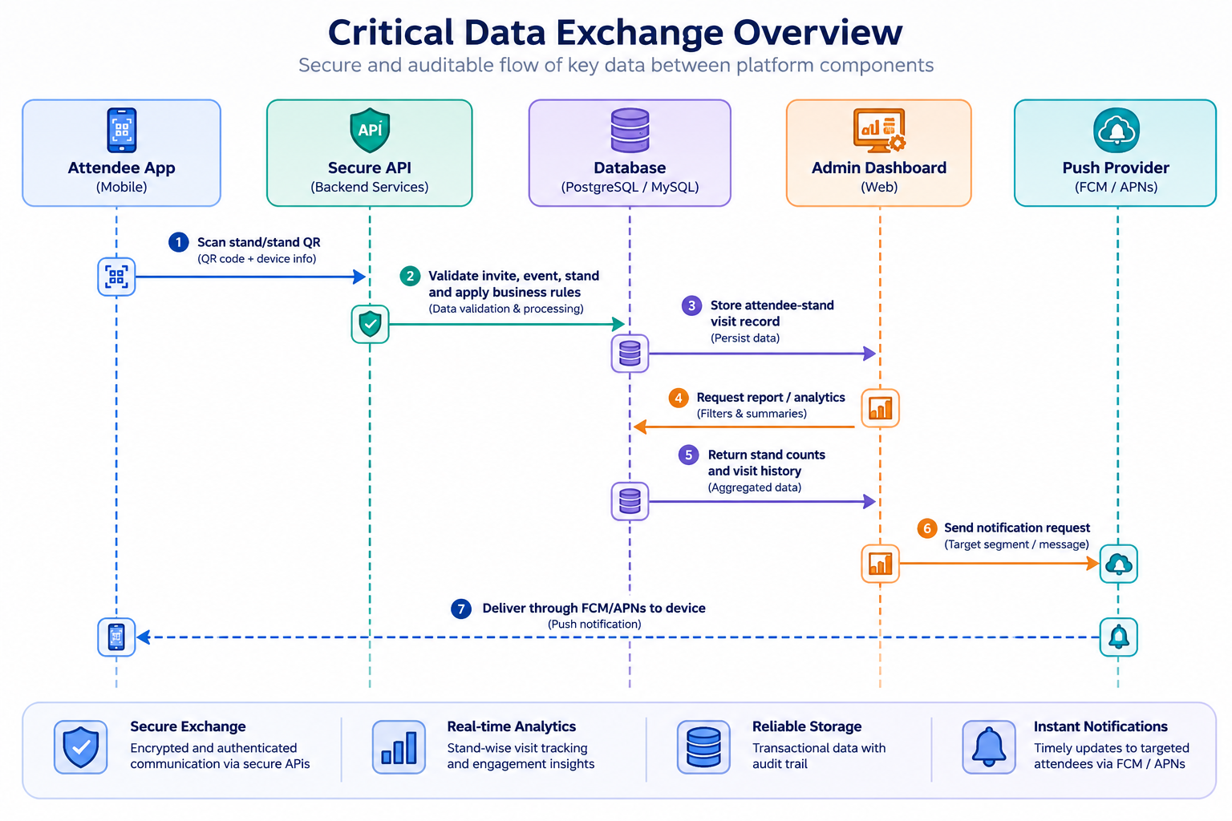
Figure 2. QR visit and push-notification data exchange

8. Development Methodology
An accelerated Agile delivery model is proposed. Work will be divided into short iterations with continuous client validation and parallel engineering, testing, and store-readiness activities.

8.1 Discovery and Scope Confirmation
- Confirm invite access method, administrator roles, report fields, duplicate-scan rule, and notification behavior.
- Review floor-plan source files and agree the optimized 2D presentation.
- Confirm brand assets, store ownership, privacy content, and event data availability.

8.2 UX/UI and Technical Foundation
- Create lightweight mobile and dashboard layouts focused on the agreed modules.
- Establish the Expo mobile project, Laravel backend, database, environments, and CI/CD baseline.
- Prototype and validate camera scanning, push token registration, and floor-plan rendering early.

8.3 Iterative Feature Development
- Develop mobile and dashboard features in prioritized increments.
- Demonstrate completed increments to the client and record focused feedback.
- Maintain scope control to protect the event deadline.

8.4 Continuous Testing and Stabilization
- Perform developer testing throughout implementation.
- Run functional, integration, device, notification, QR, offline, security, and performance checks.
- Resolve defects by priority and execute regression testing.

8.5 QA, Store Submission, and Launch
- Provide a QA build and test accounts.
- Prepare store listings, privacy information, screenshots, credentials, and signed builds.
- Submit early enough to allow review feedback and resubmission where necessary.
- Deploy the production backend and support launch readiness.

9. Proposed Technical Stack
Layer | Proposed Technology | Purpose
Mobile application | Expo + Flutter + TypeScript | Shared Android/iOS codebase with access to camera, push notifications, local storage, and native builds.
Mobile navigation/UI | Expo Router and Flutter components | Structured screen navigation and lightweight responsive mobile interface.
QR scanning | Expo Camera barcode scanning capability | In-app scanning of unique exhibitor stand QR codes.
Push notifications | Expo Notifications / Expo Push Service with FCM and APNs | Cross-platform device notification delivery and handling.
Offline storage | Expo FileSystem / local application storage | Caching floor plans and core event information on the device.
Admin dashboard | Laravel Blade or lightweight React frontend with Laravel API | Secure administration of content, QR codes, notifications, and reports.
Backend | PHP Laravel REST API | Business rules, authentication, integrations, reporting, and centralized data services.
Database | PostgreSQL or MySQL | Structured storage of users, events, stands, scans, notifications, and audit records.
Object storage | S3-compatible storage or client-approved equivalent | Storage and delivery of floor-plan and event assets.
Infrastructure | Linux cloud environment, Nginx, SSL/TLS | Secure hosting of API, dashboard, database, and assets.
CI/CD and source control | Git-based repository and automated build/deployment pipeline | Controlled releases, traceability, and environment consistency.
Monitoring and logs | Application logs and infrastructure monitoring | Operational visibility for errors, notification submissions, and API health.

10. Non-Functional Requirements
- Performance: Optimize API responses, images, floor-plan assets, and application bundles for practical loading on event networks.
- Availability: Host production services in a stable cloud environment with operational monitoring and backup procedures.
- Scalability: Design stateless APIs and indexed reporting queries so the solution can handle concentrated event-time usage.
- Usability: Keep primary actions accessible within a small number of taps and use clear feedback for scans, permissions, and connectivity.
- Compatibility: Support agreed recent Android and iOS versions and test across representative screen sizes and physical devices.
- Maintainability: Use modular code, version control, documented configuration, and reusable event-edition data structures.
- Lightweight application: Compress and resize assets, avoid unnecessary libraries, and keep large floor-plan files outside the initial bundle where appropriate.
- Offline behavior: Allow cached viewing of previously loaded floor plans and general event content; clearly identify functions that require connectivity.

11. Security and Data Protection
- Use HTTPS/TLS for all dashboard and mobile API communication.
- Apply invitation validation, secure authentication, session expiry, and role-based administration access.
- Store passwords using Laravel’s secure hashing mechanisms and avoid storing secrets in source code.
- Use non-sensitive opaque values in QR codes rather than attendee or confidential exhibitor information.
- Validate all API inputs and protect administrative endpoints against unauthorized access.
- Limit collected attendee data to information necessary for invite control, notifications, and visit reporting.
- Maintain audit-relevant timestamps and administrator activity logs for critical operations.
- Implement database backup and restore procedures appropriate to the hosting environment.
- Prepare a privacy policy and platform permission descriptions for camera and notification access.
- Configure retention and deletion expectations with the client before production launch.

12. Testing and Quality Assurance
Quality assurance will run throughout the project rather than only at the end. The release candidate will be accepted only after critical workflows pass on representative Android and iOS devices.

12.1 Functional Testing
- Invite validation and authenticated access.
- Event and exhibitor content display.
- Floor-plan zoom, pan, hotspot behavior, and offline cache.
- Valid, invalid, inactive, and duplicate QR scan scenarios.
- Notification composition, submission, device receipt, tap behavior, and in-app history.
- Report counts, filters, attendee history, and CSV export.

12.2 Integration Testing
- Mobile-to-API authentication and data retrieval.
- QR scanner-to-backend validation and database recording.
- Dashboard-to-push-service notification submission.
- Push receipt handling through Android FCM and Apple APNs pathways.
- Asset upload, optimization, publication, and device retrieval.

12.3 Device and Compatibility Testing
- Physical Android and iOS devices with different screen sizes.
- Foreground, background, and locked-screen notification scenarios.
- Camera permission granted, denied, and later enabled scenarios.
- Different network conditions, including temporary loss of connectivity.

12.4 Performance and Reliability Testing
- API response time under expected concurrent usage.
- Repeated QR scan handling and database integrity.
- Floor-plan loading, memory use, and cache behavior.
- Notification batch submission and provider-response processing.

12.5 Security Testing
- Authentication and authorization checks.
- Input validation and common web/API vulnerability checks.
- Secure transport and environment configuration review.
- Access-control verification for reports and attendee data.

12.6 User Acceptance Testing
- Provide a staged environment and release candidate.
- Execute agreed acceptance scenarios with client representatives.
- Track feedback, resolve approved defects, and obtain release sign-off.

12.7 Regression and Release Verification
- Re-test critical features after fixes.
- Verify production configuration, store builds, permissions, links, and backend connectivity.
- Run final smoke tests before store submission and after production release.

13. Deployment and App Store Publishing
- Create development, staging/QA, and production configurations.
- Prepare signed Android and iOS builds using client-owned store accounts and required credentials.
- Assist with app name, description, screenshots, privacy details, permission declarations, and support information.
- Submit the Android application to Google Play and the iOS application to App Store Connect.
- Address reasonable review feedback related to the delivered scope and resubmit builds where required.
- Deploy the production backend, database, dashboard, SSL certificate, and environment configuration.
- Provide a final release checklist and administrator handover.

14. Deliverables
- Android mobile application build and Google Play submission package.
- iOS mobile application build and Apple App Store submission package.
- Secure web-based administration dashboard.
- Laravel backend REST API and configured production services.
- Database schema for invited attendees, event editions, exhibitors, stands, QR codes, scans, notifications, and reports.
- 2D floor-plan implementation based on client-provided assets.
- Push notification implementation and administration controls.
- QR code generation/registration, mobile scanning, validation, and stand-visit tracking.
- Stand-wise, attendee-wise, and overall engagement reporting with agreed CSV exports.
- Test plan, test results summary, defect log, and QA support.
- Deployment configuration and production release support.
- Administrator handover guide and basic technical documentation.
- Source code handover through the agreed repository after completion and contractual closure.

15. Assumptions and Client Dependencies
- The client will nominate a single authorized decision-maker and provide consolidated feedback within one business day during critical stages.
- The client will provide final branding, event copy, exhibitor data, attendee invite data, floor-plan source files, stand allocation, and QR print dimensions on schedule.
- The client will own and provide access to Google Play Console, Apple Developer/App Store Connect, required legal entity information, and notification credentials or approve Riseup Labs to configure them.
- The client will provide or approve the privacy policy, support contact, terms, and store listing information.
- The client will arrange reliable event-site internet connectivity for online QR scan submission.
- The baseline floor plan will be a 2D visual asset with zoom/pan and agreed hotspots; 3D production is not assumed.
- One primary event edition is configured for the first launch, with the data model allowing future editions.
- Client-requested changes after scope approval may affect timeline and will require impact review.
- App-store review and approval are controlled by Google and Apple and cannot be guaranteed by a specific date.
- Hosting, domains, store-account subscriptions, and third-party infrastructure charges will be provided or paid by the client unless separately agreed.

16. Out of Scope
- Generic multi-tenant event management platform capabilities.
- Public event registration, ticket sales, payment gateway, invoicing, or refund processing.
- Indoor GPS, live attendee location, turn-by-turn navigation, route calculation, or beacon-based positioning.
- Advanced 3D modelling, virtual reality, or augmented reality floor-plan experience.
- Exhibitor self-service portal or exhibitor mobile application.
- Attendee social networking, chat, meetings, lead exchange, gamification, or matchmaking.
- Agenda/session booking, speaker management, live streaming, or webinar features.
- Offline QR scan queuing and later synchronization unless added through a separately approved change.
- External CRM, ERP, marketing automation, badge printer, access-control, or third-party analytics integrations.
- Custom email invitation delivery platform; the client may use its existing email process.
- Ongoing operations, content entry, post-launch maintenance, or hosting management beyond the agreed handover/support period.

17. Conclusion
The proposed solution directly addresses the client’s three critical priorities while keeping the first release practical for the 6 September 2026 event. By using a shared Expo Flutter mobile codebase, a Laravel backend, early physical-device validation, and a disciplined accelerated delivery plan, Riseup Labs can provide a focused expo application that supports communication, exhibitor engagement tracking, and floor-plan discovery without unnecessary platform complexity.
Successful delivery depends on immediate access to client assets and store accounts, rapid decision-making, and strict scope control throughout the seven-week implementation window.

